Russell Silva

4/24/2018

AMRUPT, Spring ‘18

Weekly Report #7 – Synchronous Sampling on GNU Radio and RF Switching

**Goals**

Last week, synchronous I/Q extraction from multiple SDRs on GNU radio was completed. Figure 1 shows the basic block diagram to display the real/imaginary values of an incoming RF signal (WVBR Ithaca radio station) in the time domain. Figure 2 shows the result of the block diagram in Figure 1. Peidong and Justin assisted me in completing these tasks last week. The goals for next week will be completing a fundamental GNU Radio flowchart with cross correlation and phase bias correction that will obtain rudimentary AOAs (Peidong and I). This will require a successful integration of RF Switching with external noise sources (Justin and I). Although testing will be a significant task for optimizing our system (best sampling rate, interpolation techniques, etc.), I suggest that the whole team can focus efforts on the most significant task of obtaining preliminary angle of arrival measurements this week.

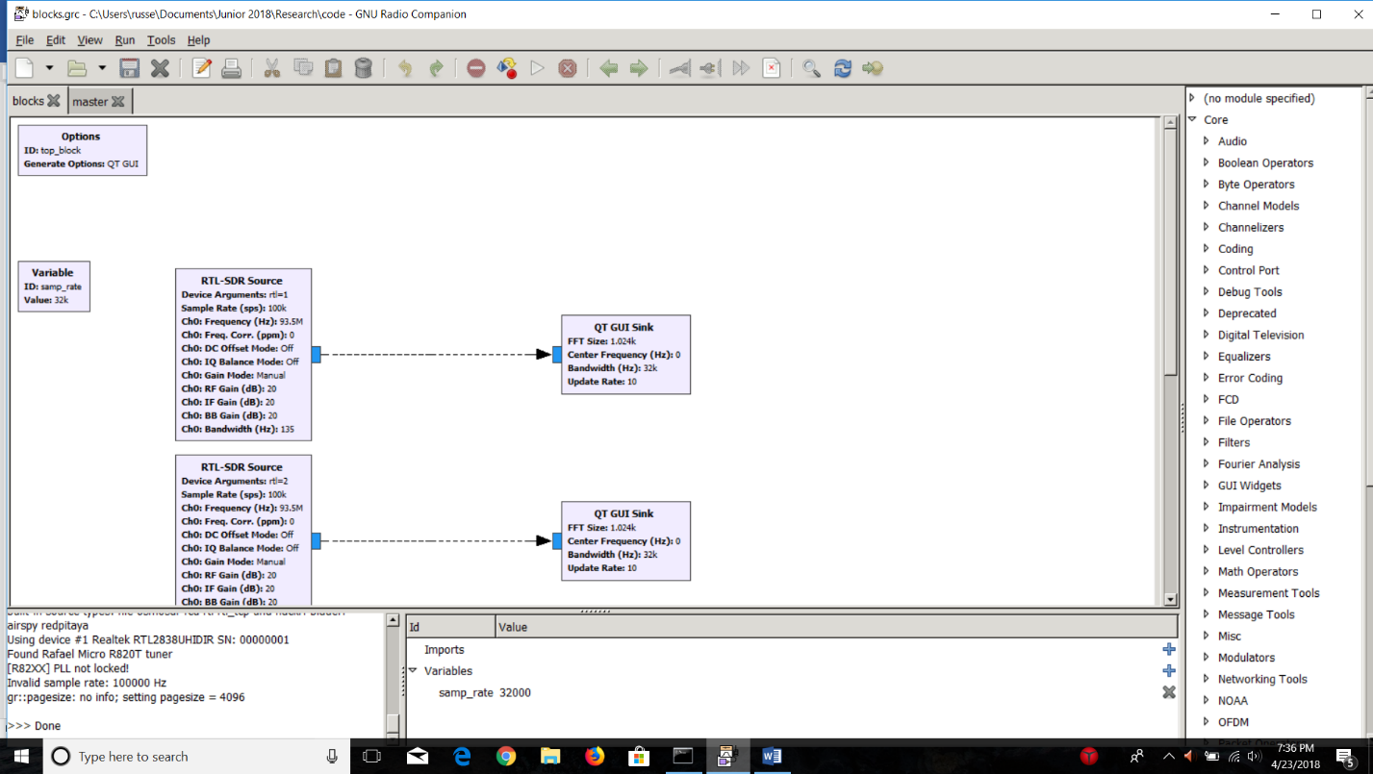

**Problems**

**Figure 1: Basic Real-Time I/Q Extraction**

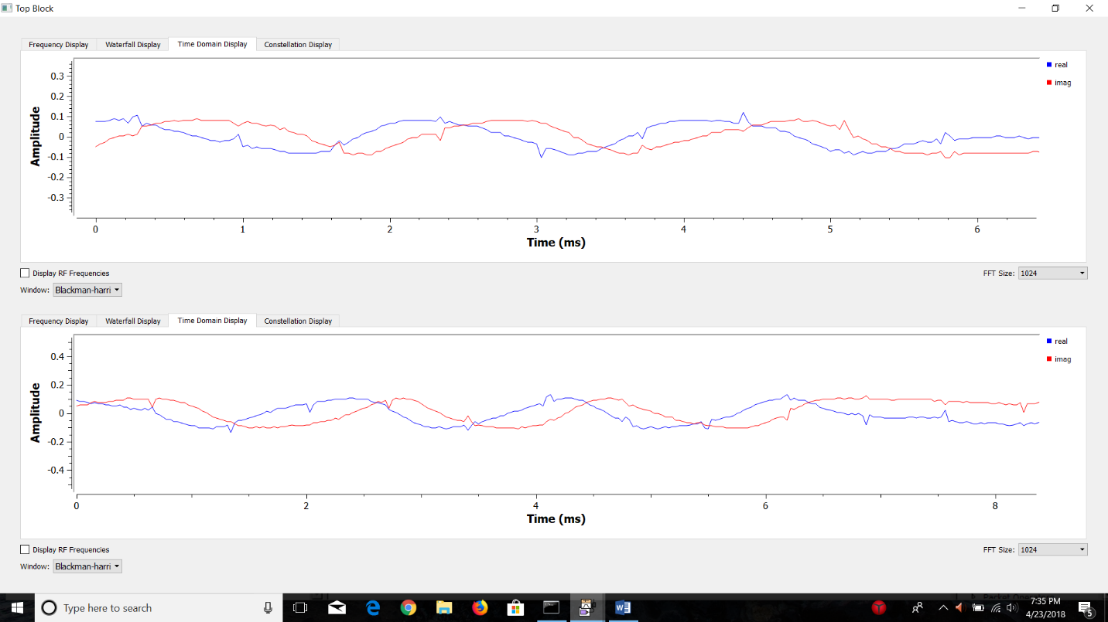

**Figure 2: I/Q (Real and Imaginary) Samples in the Time Domain**

**Problems**

1. We have been experimenting with flowcharts and custom GNU Radio Blocks from Sam Whiting’s GitHub (<https://github.com/samwhiting/gnuradio-doa>). One of these flowcharts is shown in Figure 3. Obstacles with executing these files included finding out how to program, integrate, and install custom blocks into GNU Radio. Most of our problems in these areas have been solved by moving custom block code to the GNU Radio root directory (will be detailed in a future tutorial). The current problem we are facing now is the GNU Radio code has runtime errors due to missing python modules. This could be due to a Python to C++ conversion in Sam Whiting’s project for more efficient DOA analysis.
2. We are still having trouble finding an external noise input on the coherent receiver.
3. We will need shielded, low loss wires to separate our antennas while mitigating noise at RTL SDR inputs and along wire connections.

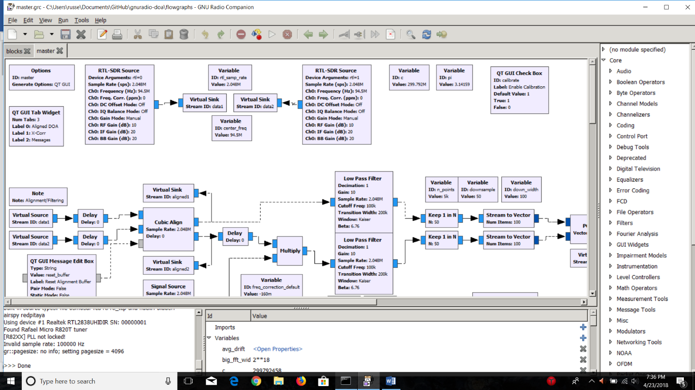

**Figure 3: DOA Methodology – Sam Whiting, et al.**

**General Approach**

1. If we follow a ground up approach, with Sam Whiting’s custom block code and flowchart methodology as a reference, we could avoid the current GNU Radio problem and future issues with embedded code by programming the entire system from scratch (this will make debugging easier since we will have written the code).
2. The director of coherent receiver has been emailed to help us with our difficulty in finding an external noise source input on the noise expansion card. We have already perused over (<https://coherent-receiver.com/products/rtl-sdr-extension-card/noise-source>) and (<https://coherent-receiver.com/support>) to try to find this connection.
3. After a thorough search of male to female SMA connectors, I have found the following to optimal:

Four antenna separation by utilizing eight LMR-200 Male to Female SMA Connectors:   
<https://www.data-alliance.net/sma-extension-cable-3-foot-sma-male-to-female-w-bkd-lmr-200-100-equiv/>

(~$50 total)

Eight 6-inch connectors for small distance adjustments (~$40 total):  
<https://www.data-alliance.net/sma-male-straight-to-sma-female-right-angle-cable-3-inch-4-in-6-in-8-in-20-in-22-inch/>